NEWSAN MARKS MENSTRUAL HYGIENE MANAGEMENT (MHM) DAY 28TH MAY, 2020.

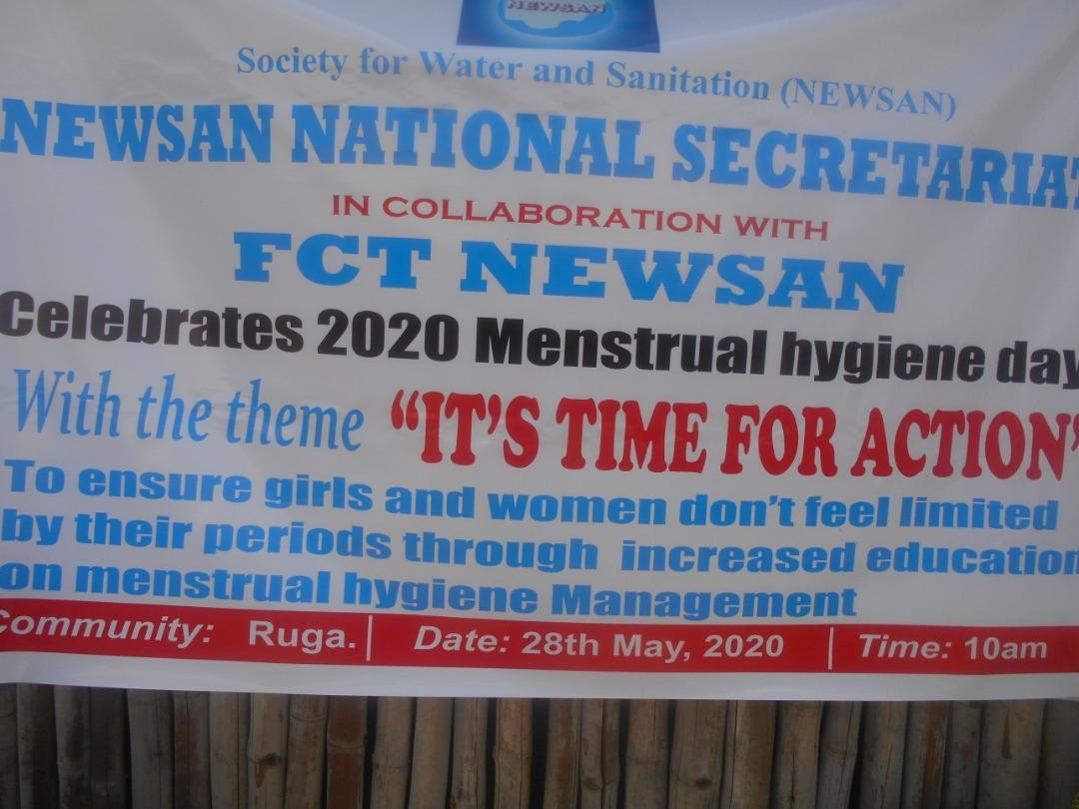

NEWSAN National Secretariat in collaboration with the FCT chapter, the MHM Technical working Group and WSSCC mark the 2020 Menstrual Hygiene Day with Ruga community in FCT, Abuja.
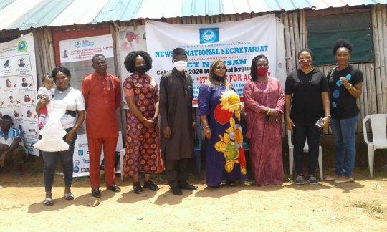

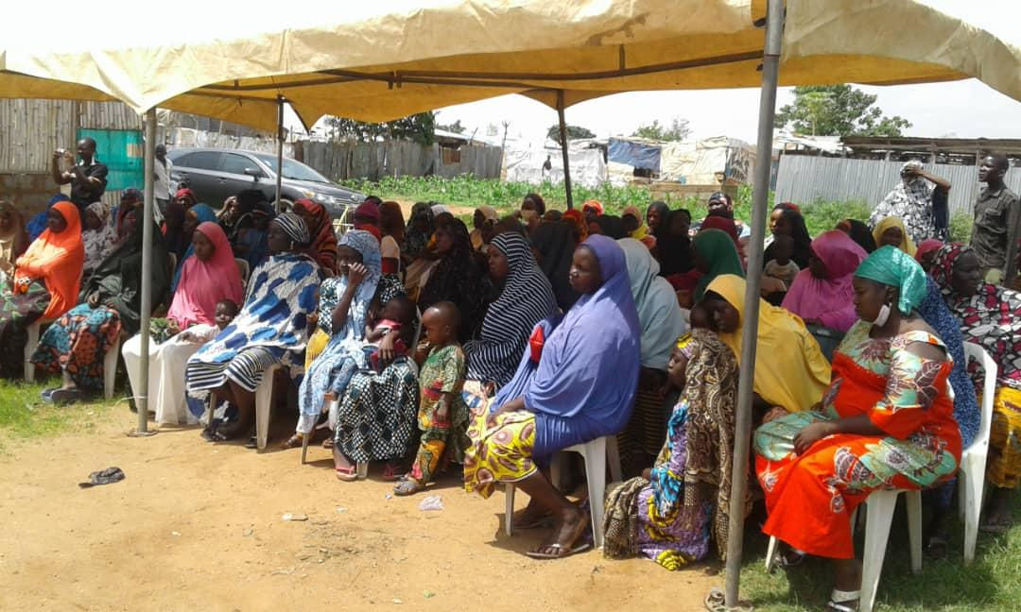RUGA COMMUNITY WOMEN WAITING FOR THE COMMENCEMENT OF THE PROGRAMME.
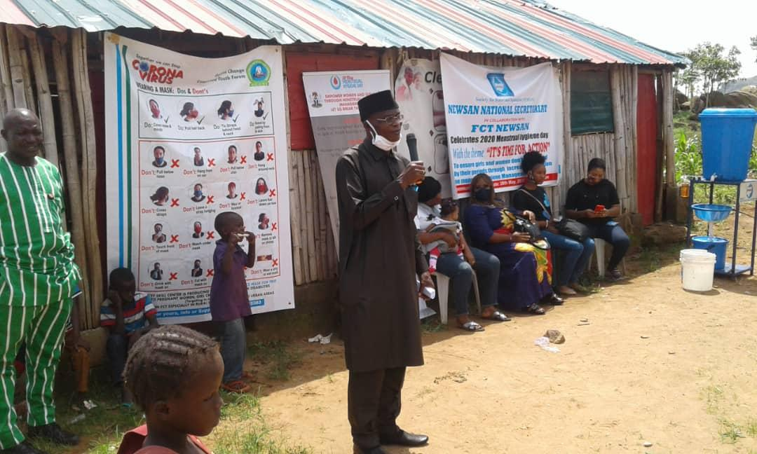
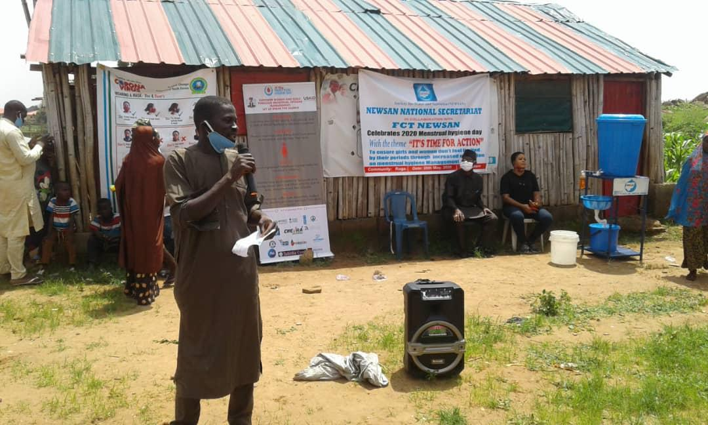
OPENING PRAYER BY ONE OF THE REPRESENTATIVES OF RUGA COMMUNITY.
NEWSAN NATIONAL COORDINATOR, MR. BENSON ATTAH, GIVING AN OPENING SPEECH AND WELCOMING THE RUGA COMMUNITY WOMEN.
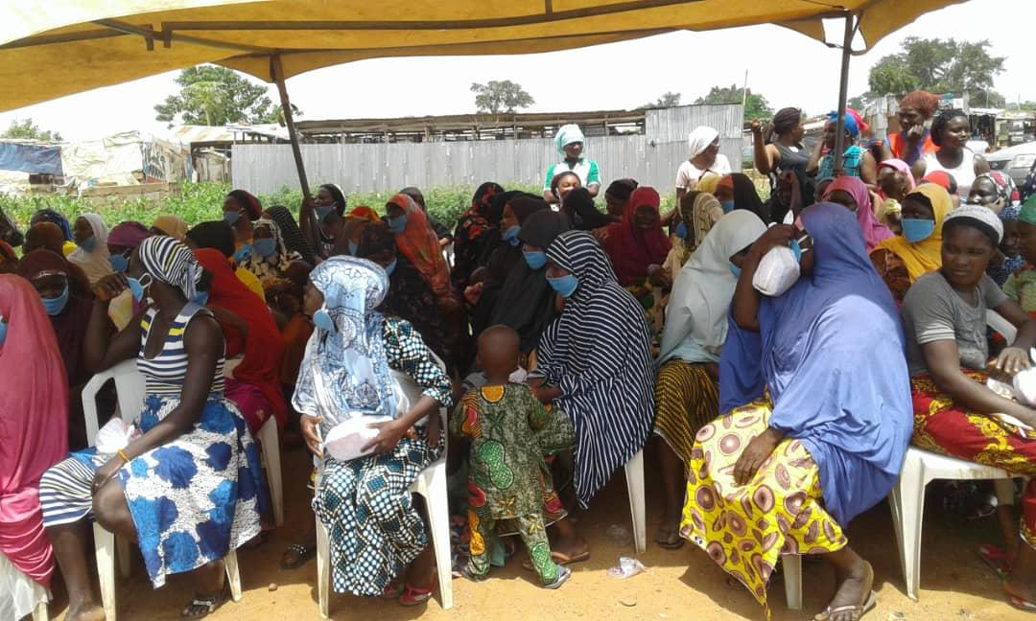RUGA COMMUNITY WOMEN PUTTING ON THEIR FACE MARKS, (DISTRIBUTED BY NEWSAN) BEFORE THE START OF THE PROGRAMME.
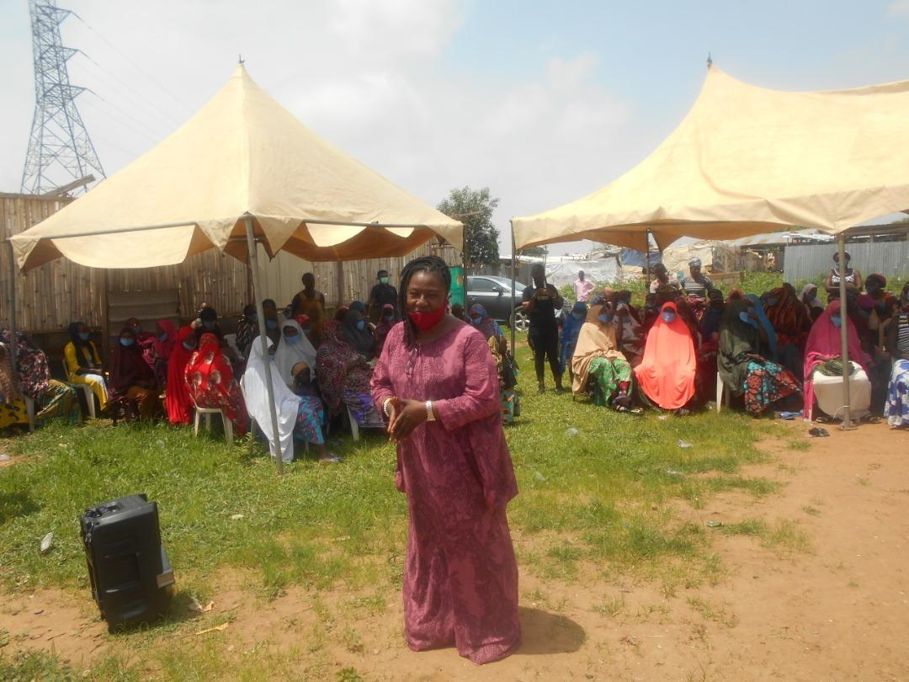THE NATIONAL COODINATOR OF WSSCC, MRS ELIZABETH IJIEYOL, GIVING A GOODWILL MESSAGE TO RUGA COMMUNITY WOMEN.

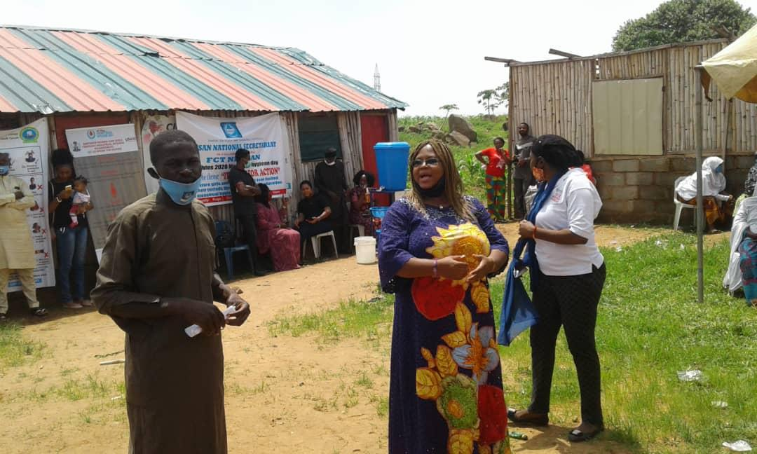SPEECH BY A REPRESENTATIVE OF MINISTRY OF WOMEN AFFAIRS.

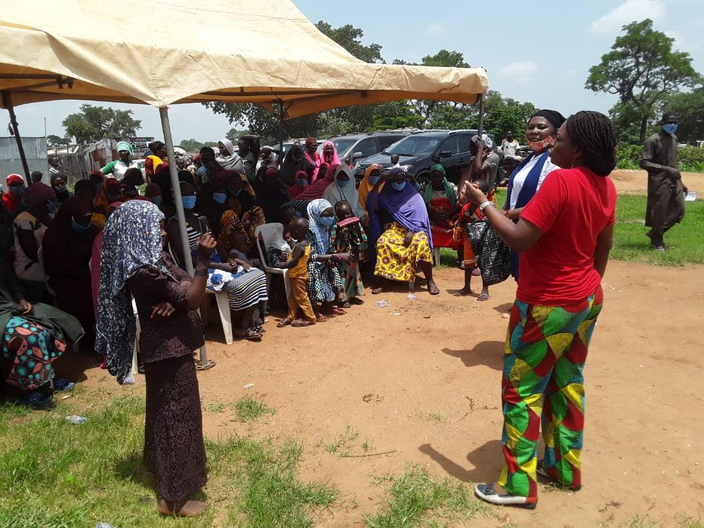
A REPRESENTATIVE OF WATER AID, MRS SEYI OLA, GIVING A SENSITIZATION TALK ON MENSTRUAL HYGIENE TO RUGA WOMEN IN THEIR INDIGENOUS LANGUAGE.
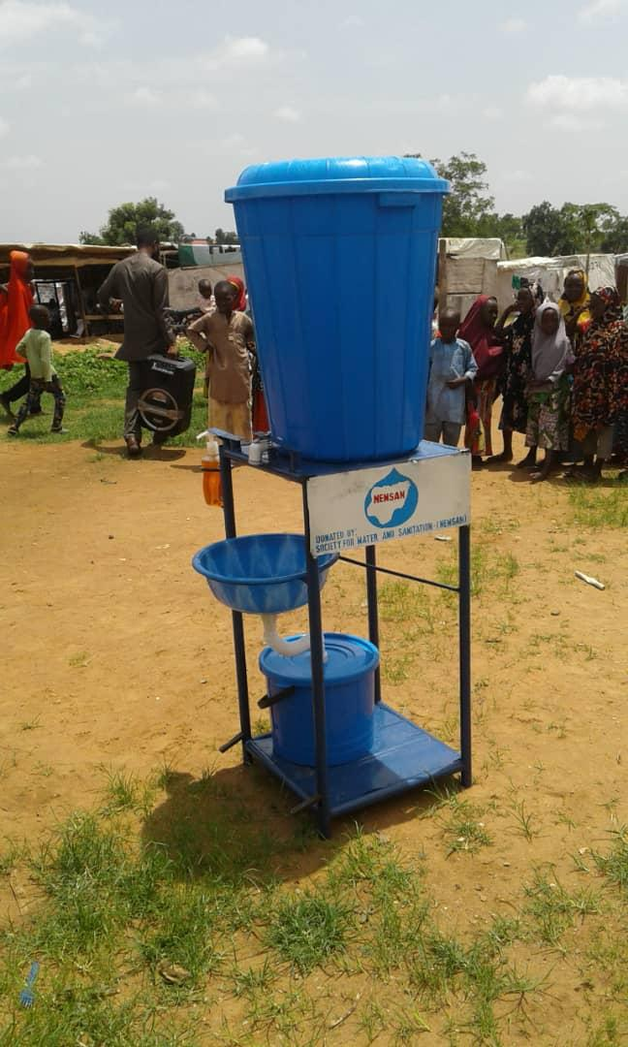HAND WASHING FACILITY DONATED BY NEWSAN TO THE RUGA COMMUNITY POPULACE.

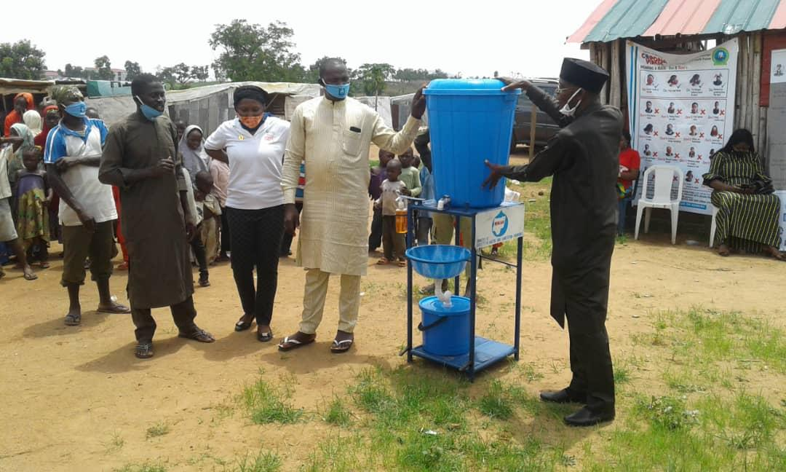NEWSAN NATIONAL COORDINATOR, MR BENSON ATTAH EXPLAINING THE OPERATIONS OF THE HAND WASHING FACILITY TO SOME OF THE REPRESENTATIVES OF RUGA COMMUNITY.
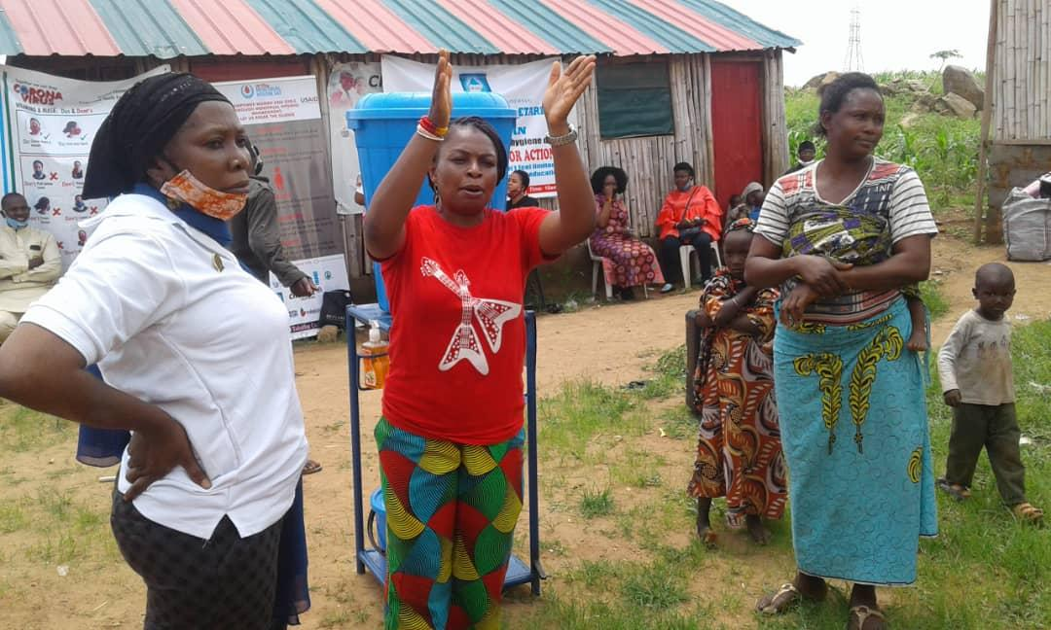NEWSAN PROGRAMME OFFICER, MISS BIBIAN AMA (LEFT) AND MRS SEYI OLA (RIGHT) DEMONSTRATING HAND WASHING.

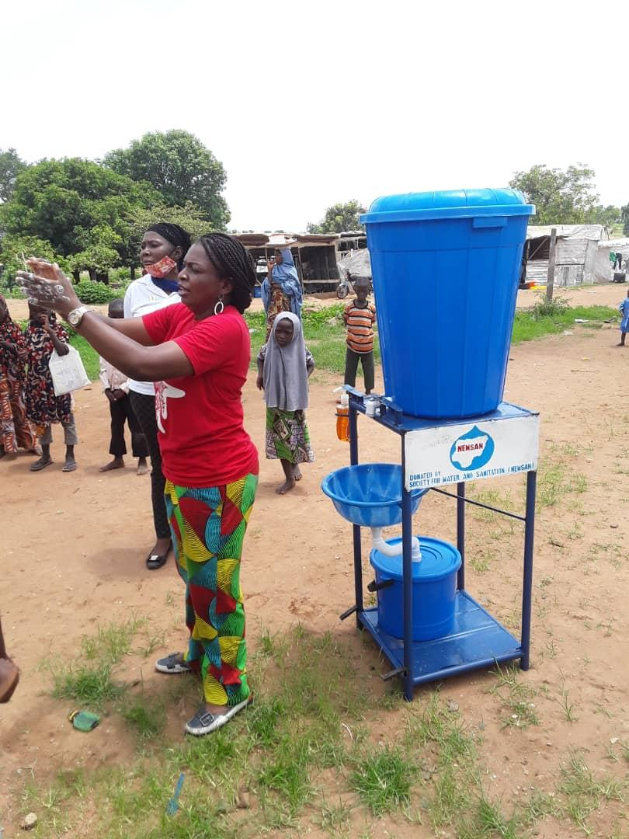DEMONSTRATION OF PROPER HAND WASHING WITH SOAP AND WATER.
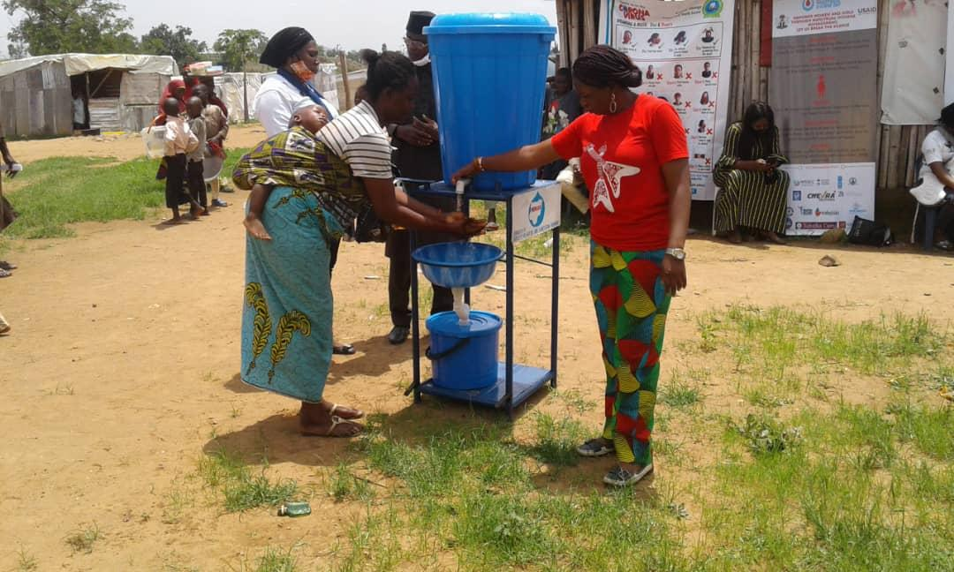A RUGA COMMUNITY WOMAN BEING GUIDED TO WASH HER HANDS USING THE WATER FACILITY.
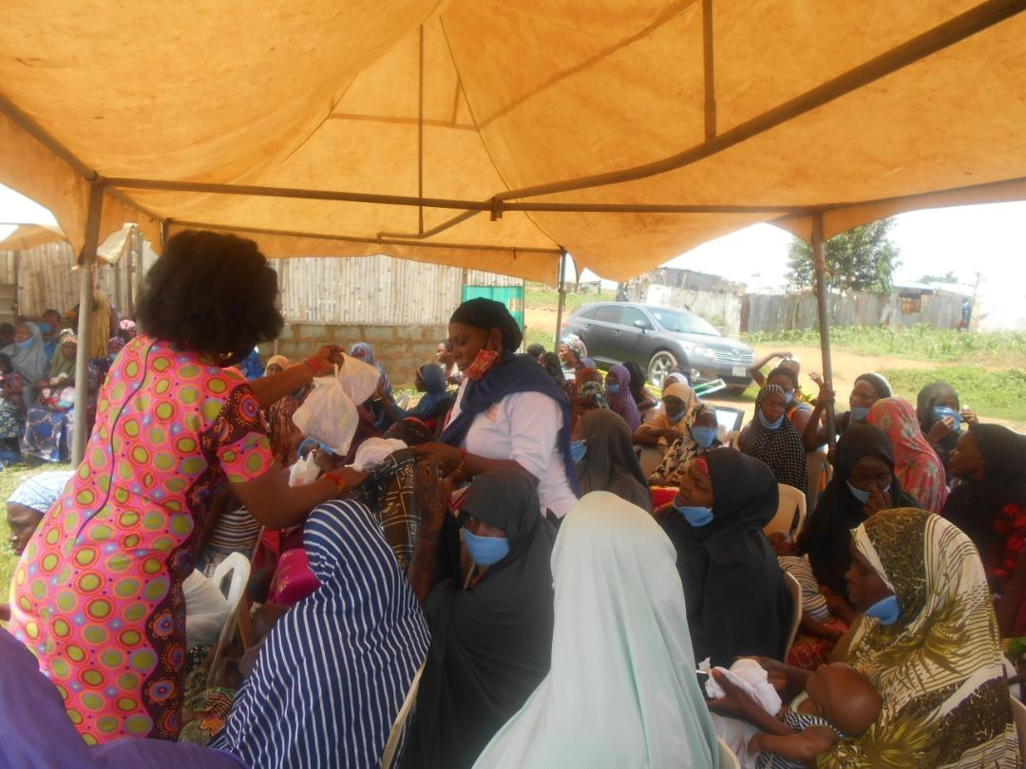SHARING OF MENSTRUAL MATERIALS TO RUGA WOMEN BY THE TECHNICAL WORKING GROUP.
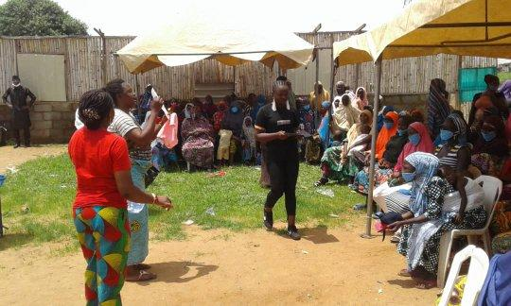
A BENEFICIARY OF MENSTRUAL MATERIALS DEMONSTRATING THE USE OF MENSTRUAL PAD TO HER FELLOW WOMEN.
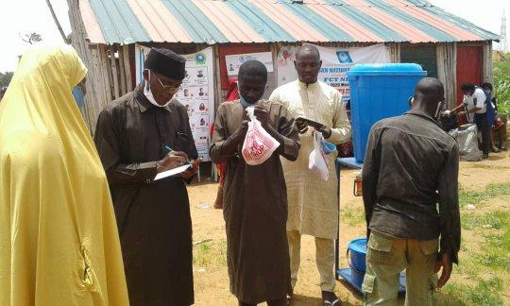NEWSAN NATIONAL COORDINATOR, MR. BENSON ATTAH EXCHANGING CONTACTS WITH SOME OF THE REPRESENTATIVES OF RUGA COMMUNITY.

